1. Select Your Operating System (OS):
Choose an operating system that best suits your preferences and project requirements. Download and Install Windows 11. https://www.microsoft.com/software-download/windows11

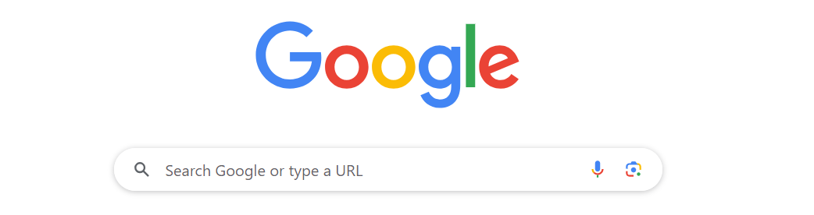
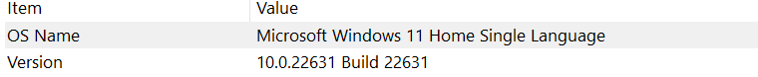

The operating system i chose is Google and I am using windows 11 in my laptop

Install a Text Editor or Integrated Development Environment (IDE):
Select and install a text editor or IDE suitable for your programming languages and workflow. Download and Install Visual Studio Code. https://code.visualstudio.com/Download

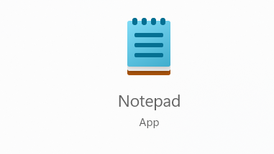
The text editor is Notepad
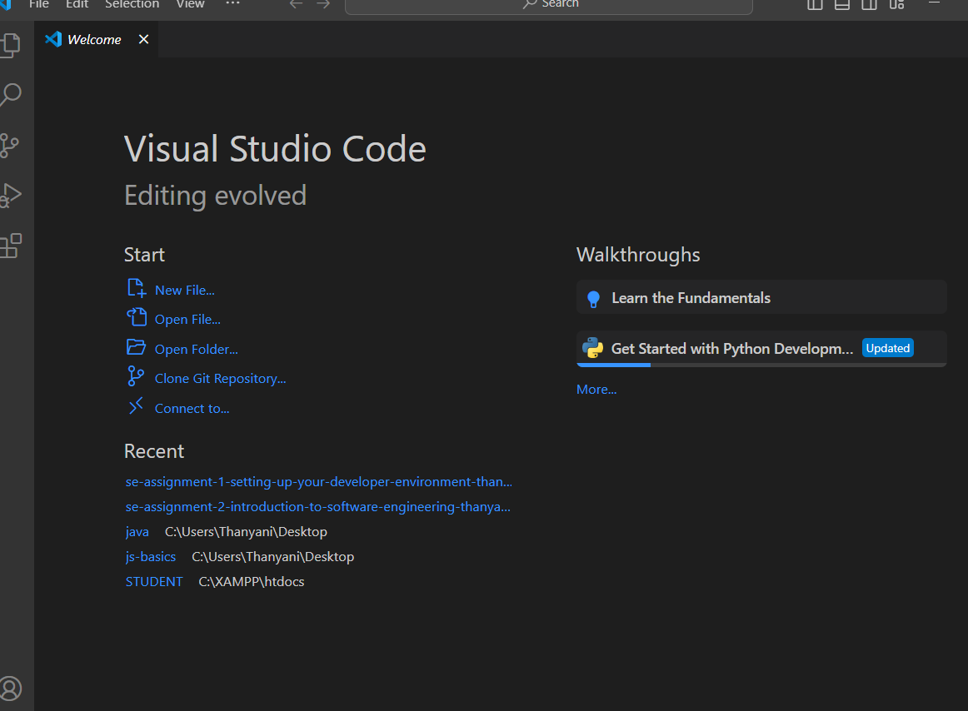

3. Set Up Version Control System:
Install Git and configure it on your local machine. Create a GitHub account for hosting your repositories. Initialize a Git repository for your project and make your first commit. https://github.com

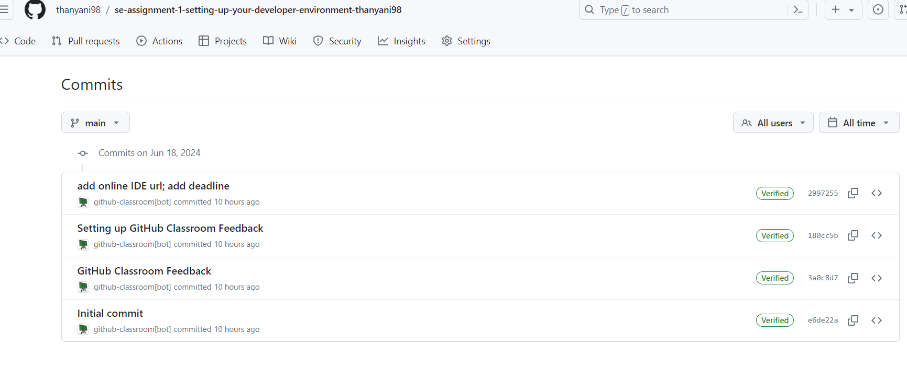

4. Install Necessary Programming Languages and Runtimes:
Instal Python from http://wwww.python.org programming language required for your project and install their respective compilers, interpreters, or runtimes. Ensure you have the necessary tools to build and execute your code.

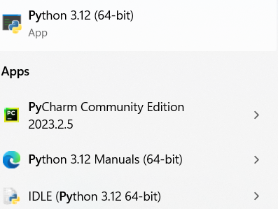

5. Install Package Managers:
If applicable, install package managers like pip (Python).

6. Configure a Database (MySQL):
Download and install MySQL database. https://dev.mysql.com/downloads/windows/installer/5.7.html

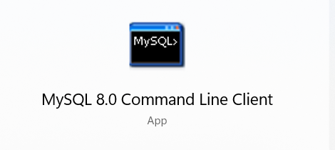

7. Set Up Development Environments and Virtualization (Optional):
Consider using virtualization tools like Docker or virtual machines to isolate project dependencies and ensure consistent environments across different machines.

8. Explore Extensions and Plugins:
Explore available extensions, plugins, and add-ons for your chosen text editor or IDE to enhance functionality, such as syntax highlighting, linting, code formatting, and version control integration.

I encounter problems on this part and i need further explanations in order to understand it

9. Document Your Setup:
Create a comprehensive document outlining the steps you've taken to set up your developer environment. Include any configurations, customizations, or troubleshooting steps encountered during the process.

The process was very much fun i learnt a lot, I learnt something I didn’t know exists and as a future developer this really helped me a lot even though I encounter challenges along the way but giving up was not an option some of the environment after downloading didn’t run so i had to delete them and download them over and over again,I haven’t fully understand some of the processes but i’m willing to learn as time goes on.

